**SERMON NOTES:** TITLE: STAR POWER

SPEAKER: Pastor Brad Kuechler December 6, 2020

**THE STAR OF JESUS TEACHES US 3 WAYS TO BE LED BY THE HOLY SPIRIT**

***#1 – SEEKING WHAT IS ___________ GIVES ACCESS TO THE THINGS ABOVE (Mt 2:1)***

**How to win the battle of the mind**

* **#1 - ____________ your mind on things above (Col 3:2)**
  + **The Greek word for “set our mind” is Phroneo which means to _______________ the mind or ____________ the mind**
* **#2 – Take every _______________ captive (2 Cor 10:4)**
* **#3 – Believe you ______________ (Phil 4:13)**

**__________________________________________________________________________________________________________________________________________**

**#2 – KNOWING THE WORD RELEASES THE ________________________ (Mt 2:5-6)**

**Three things the word does in the life of a believer**

* **#1 – It _______________ the mind (Eph 4:22-24)**
  + **The Greek word for “renewed” is ananeoo which means**
    - **To _______________ or to _______________**
* **#2 – It _________________ our character (Rom 5:3-4)**
  + **The Greek word “character” is “dokime” which includes the idea of “approved as a result of ___________________”**
* **#3 – it _________________ our life (Ps 119:105)**
  + **The Hebrew word for “lamp” is “nerah” which means a ________**

**__________________________________________________________________________________________________________________________________________**

**#3 – USING YOUR GIFTS __________________ HEAVENLY GIFTS (Mt 2:11)**

**Three keys to the Magi-Gift**

* **#1 – Gold = giving God your ________________ (Ps 72:15)**
* **#2 – Frankincense = giving through the _______________ (Is 60:6)**
* **#3 – Myrrh = giving up your old _____________ (Ps 45:8)**

**__________________________________________________________________________________________________________________________________________**

**MORE NOTES:**

**__________________________________________________________________________________________________________________________________________**

**__________________________________________________________________________________________________________________________________________**

**__________________________________________________________________________________________________________________________________________**

***_____________________________________________________________________***

WELCOME TO…

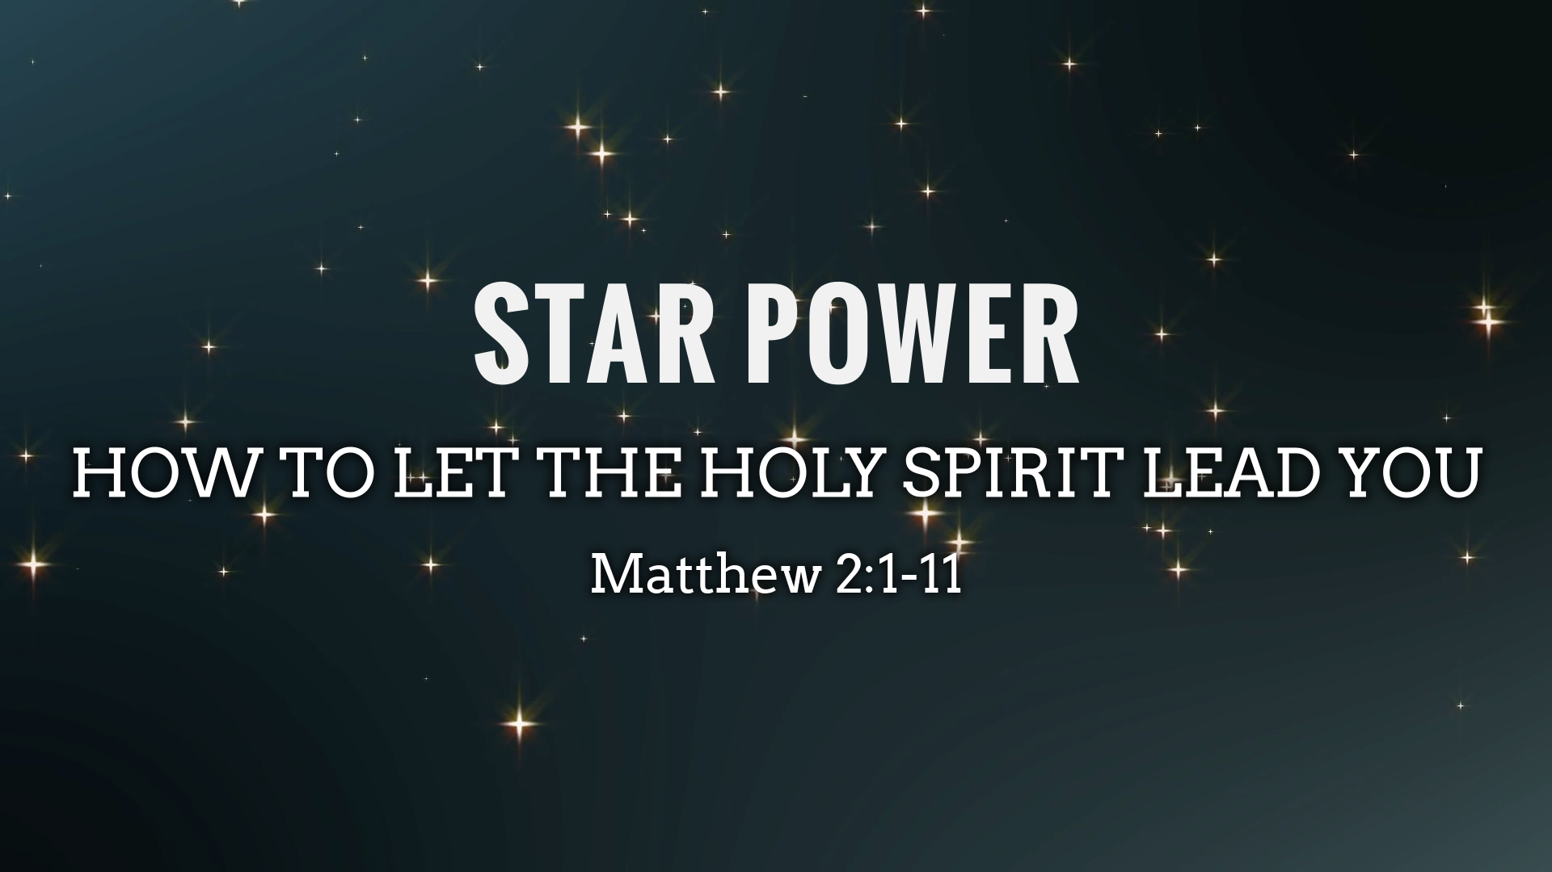

**Today’s Message**

ONE CHURCH….TWO LOCATIONS

**SAN PEDRO CAMPUS**

2500 Via Cabrillo Marina #304

San Pedro, CA 90731

Sunday Services: 10:30am

**THE VALLEY CAMPUS**

15055 Oxnard St

Van Nuys, CA 91411

Sunday Services: 5:00pm

DECEMBER 6, 2020

**ROCK SOLID CHURCH OF THE SOUTH BAY**

**MAIN WEEKEND WORSHIP SERVICE – Sundays @ 10:30am**

--Location: 2500 Via Cabrillo Marina, San Pedro, CA 90731

**MIDWEEK HOME BIBLE STUDY – Thursdays @ 7pm**

--Location: 2275 W. 25th St, San Pedro, CA 90732

**YOUTH AND YOUNG ADULTS CHURCH – Fridays @ 6:30pm**

--Location: 2275 W. 25th St, San Pedro, CA 90732

--AGES 10-19

**GET YOUR FREE GIFT**

WELCOME TO ROCK SOLID! Please remember to fill out the “GUEST CARD” and turn it in for a free gift. If you need anything, please talk to one or our friendly and helpful greeters.

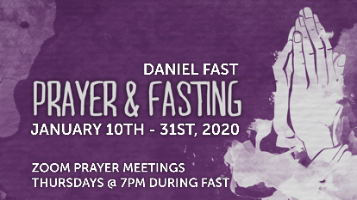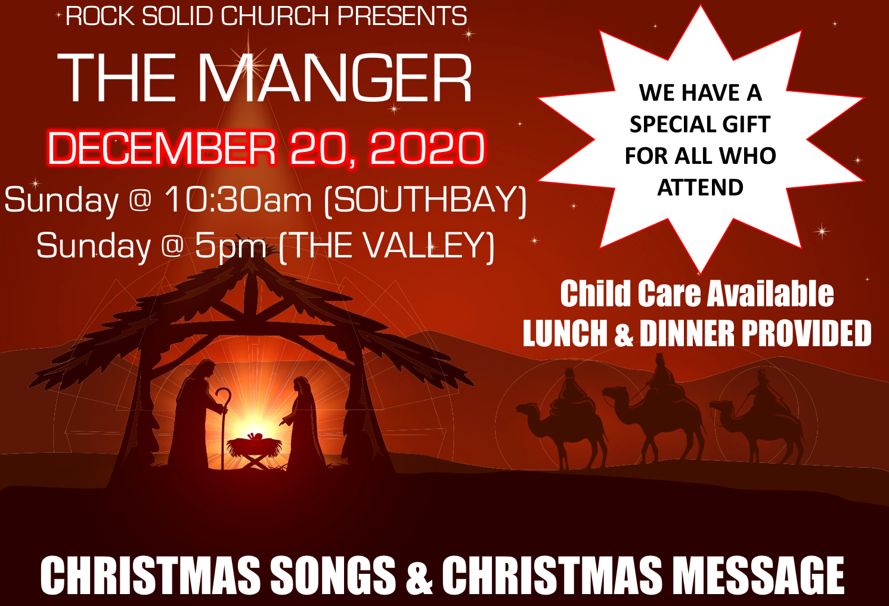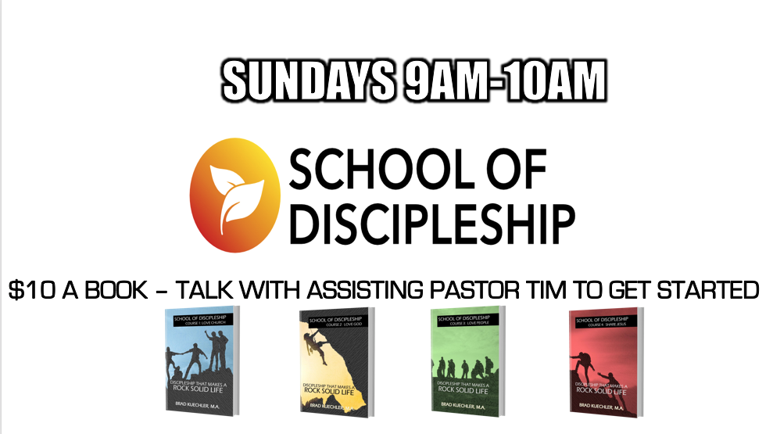

**SOUTH BAY AND VALLLEY CAMPUS EVENTS, NEWS AND MORE**

WEEKLY SCHEDULE

NEW TO ROCK SOLID?

**ROCK SOLID CHURCH OF THE VALLEY**

**MAIN WEEKEND WORSHIP SERVICE – Sundays @ 5:00pm**

--Envision Center: 15055 Oxnard St, Van Nuys, CA 91411

**MIDWEEK ONLINE BIBLE STUDY – Thursdays @ 7pm**

--JOIN US ON ZOOM AT… ZOOM.US/J/95700612770

**YOUTH AND YOUNG ADULTS CHURCH – Fridays @ 6:30pm**-

--JOIN US ON ZOOM AT… ZOOM.US/J/98552813978

--AGES 10-19

Pastor Brad & Carolyn Kuechler have pastored RS since 2001. They pastor one church in multiple locations. They love God and people. Say hello to them before you leave. They would love to meet you and pray with you.

**MEET OUR SENIOR PASTORS**

Take our “NEXT CLASS” and grow your faith and become a member of Rock Solid. You can also join our Thursday Night RSgroup Home Bible Study in person at 2275 W. 25th St, SP. You can also join through Zoom at ZOOM.US/J/95700612770.

**GET CONNECTED**